BookIT

**Student 1 Name:**  Michael Kelly

**Student 1 ID:** s00153921

**Student 2 Name:** Adam Lee

**Student 2 ID:** s00174787

**Programme:** Web Programming 3

**Submission Date:** 11/12/16

**Github Link:** https://github.com/s00174787/web3.git

Table of Contents

[Chapter 1 Overview 4](#_Toc469089420)

[Chapter 2 Research 4](#_Toc469089421)

[2.1 Similar Systems 4](#_Toc469089422)

[2.2 Technologies 4](#_Toc469089423)

[Chapter 3 Design and User Interface 5](#_Toc469089424)

[3.1 User Interface 5](#_Toc469089425)

[5](#_Toc469089426)

[6](#_Toc469089427)

[3.2 Overall Architecture 9](#_Toc469089428)

[Chapter 4 Work Breakdown 10](#_Toc469089429)

[Chapter 5 Functionality and Design 10](#_Toc469089430)

[5.1 Custom Routing 10](#_Toc469089431)

[5.2 Google API Login 10](#_Toc469089432)

[5.3 PayPal Checkout 10](#_Toc469089433)

[5.4 SSL 11](#_Toc469089434)

[5.5 Ticketmaster API 11](#_Toc469089435)

[5.6 Stripe API 11](#_Toc469089436)

[5.7 Shopping Cart 11](#_Toc469089437)

[Chapter 6 References 11](#_Toc469089438)

[Chapter 7 Appendices 11](#_Toc469089439)

# Overview

We want to design and build a website that will give our users a simple yet effective way to purchase tickets online and receive the latest news of events and other information all in one website. We would like to offer our users the opportunity to create an account for purchasing tickets for events all over Ireland and keep track of the news coming up to these events. There will also be artist bios and news on upcoming events for all artists, also previous event details we maybe include a comments section so user who hold accounts with us can leave comments on the event if they attended and how their experience was at the event. We are aiming for a visual website but we aim to keep it simple for easy navigation and quick purchases. We have added an events planner section as to not cause any confusion for regular customer registration but login for customer, event planner and administration is all from the one login page.

# Research

## Similar Systems

**Ticketmaster-** Ticket sales, user ability to select favourites from a list of categories, login to the site to access their previous bought tickets and upcoming events that they might like.

**Tickes.ie-** The user will have the ability to search for music or browse through a page with categories, the user will also be able to do a search for tickets based on the person they are wishing to acquire tickets for.

**Ticketbooth-** The user will be able to browse through a gallery of images based on the selected event, the user will also be able to post reviews and view other reviews before buying a ticket.

**Ticketofficesales-** The user will be able to keep up to date with a news feed that will tell them if an event has been cancelled or there has been a time change.

## Technologies

**Bootstrap-** for the responsiveness of the site.

**Visual studio-** for the code editor, Database design and the CSS design.

**Stripe-** this will be used for the payment methods.

**PayPal-** If users would like to use PayPal to make payments we also offer this option.

**Google API-** To give users the ability to log in using there Gmail account.

**Ticketmaster- <MICHAEL>**

# Design and User Interface

## User Interface

From the wire frames the design of the website can be seen even back in the early stages of development. Although many features were added or removed the only feature that was never used in the header were the social media icons, we realised early on that placing the icons in the header would take up essential space that we required for navigation.

## 

## E:\Year 3\WebProgramming3\Assign1Document\IMG_0563.JPG

At the current version of the website we felt it was unnecessary to have profile pictures as there is no profile to profile communication although with more time we would like to incorporate this feature into our website to allow our users to buy, sell and trade tickets directly form out website.

## E:\Year 3\WebProgramming3\Assign1Document\IMG_0564.JPG

The contact us page is almost identical to the wireframes and was all was intended to be simple and easy to use and navigate to.

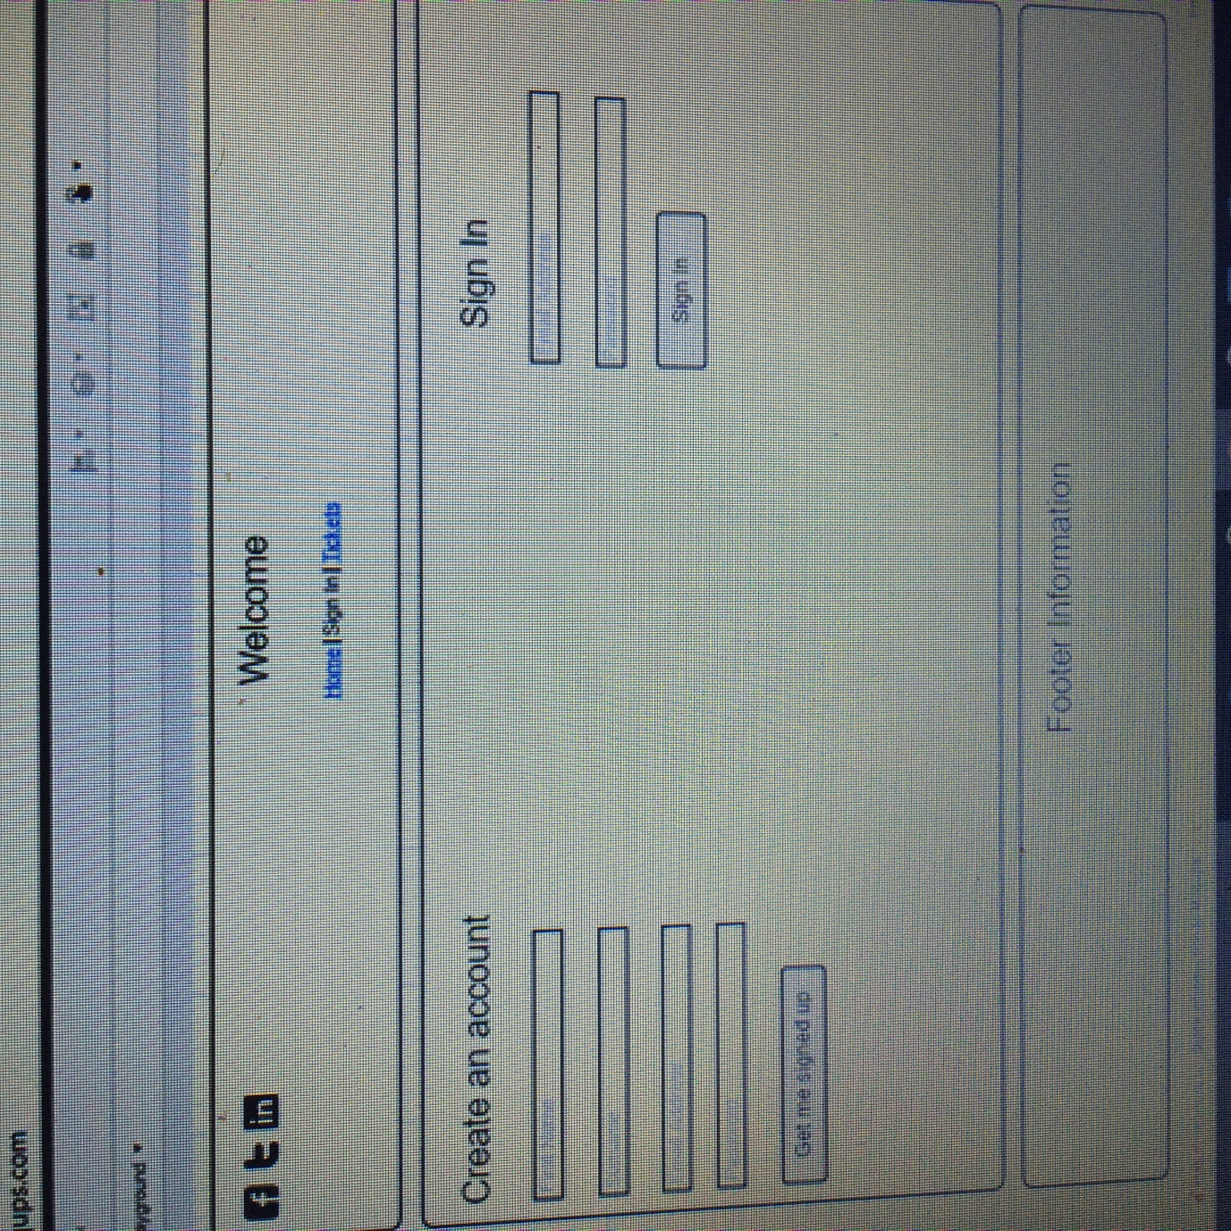

To avoid confusion, we divided this page into three separate pages, the log in, customer registration and event planner registration. The design has stayed identical to the wireframes from the early development stages.

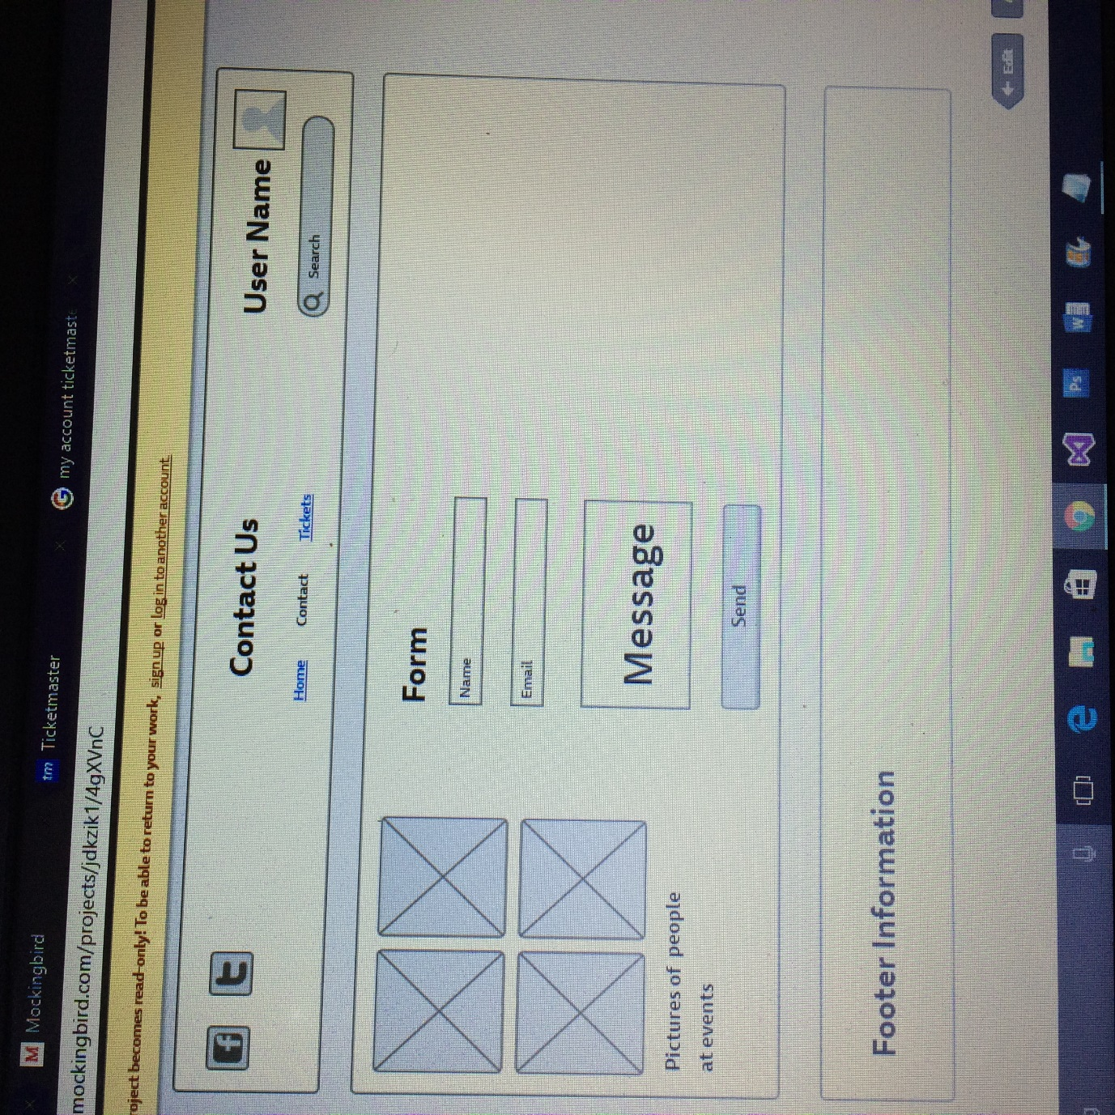

## Overall Architecture

C:\Users\adaml\AppData\Local\Microsoft\Windows\INetCacheContent.Word\Web3SiteMap.png

The site map above is the final version of the sitemap we have decided to stay with the design as it is simple, easy to navigate. If there is time towards the end of the project more pages may be added to give a more realistic view of what we would like the website to look like if we had more time for development. The webpages will include data pulled directly from the database and will update when tickets are sold out or new dates for events have been added etc.

The site map account section (the yellow section of the sitemap) as changed slightly as we split up the registration page and gave separate log in pages for customers and event planners to avoid any confusion among users.

# Work Breakdown

ERD Diagram – Adam Lee

User Interface Design – Adam Lee & Michael Kelly

Database Design & Implementation – Adam Lee

Sitemap Design – Adam Lee

Documentation – Michael Kelly and Adam Lee

User Stories - Michael Kelly and Adam Lee

Wire Frames – Michael Kelly

Bootstrap – Michael Kelly

User Login and Registration – Adam Lee

SSL – Adam Lee

Google API Login – Adam Lee

Administration Page and Functionality – Adam Lee

Ticket Master API – Michael Kelly

Stripe API – Michael Kelly

Event Planner Login and Registration – Adam Lee

Shopping cart functionality and design – Adam Lee

PayPal Checkout – Adam Lee

Custom Routing – Adam Lee

User Review – Michael Kelly

Price Checker Delegate – Michael Kelly

# Functionality and Design

## Custom Routing

Custom Routing was added to enables the web application to use URLs that are friendly, easier to remember, and better supported by search engines.

## Google API Login

We added this functionality to simply allow users to use their Gmail login rather than register with us.

## PayPal Checkout

We decided that adding additional functionality for checkout would greatly improve are website. Unfortunately, we never succeeded due a small error but if the error is fixed the checkout will be completed and the order will be added to the database.

## SSL

SSL was added for establishing an encrypted link between a web server and a browser. This link ensures that all data passed between the web server and browsers remain private and integral.

## Ticketmaster API

This api was used so the user can see events that are coming up on the ticketmaster page so they can go directly to their site and book an event with them.

## Stripe API

The stripe api was used for the user to purchase a ticket from the shopping cart. After a lot of issues, I got it to display a checkout widget where the user can enter their card details and they will get a confirmation text thanking them.

## Price Checker delegate

I used the delegate so the user can enter the price of their ticket along with a discount price and it will work out the cost of their ticket.

## Bootstrap

I used bootstrap to make the site responsive as you will see in the screenshots below. It was used on all the pages including the navbars, tables, div sect to make the experience the same on a tablet or a mobile.

## User Review

This will allow the user to fill in a simple form with their email, company email, subject and thoughts, this will then get sent to the company. This will only work if there is a working smtp server. There is also the users ability to review the site which will then be stored in the database using ajaxtoolkit.

## Shopping Cart

Shopping cart was the main functionality needed for our website to become an operational store for events. This was created to allow our users to store their tickets and add, update and delete the tickets as they wish before proceeding to checkout.

# Screenshots of the responsiveness

## Navbar

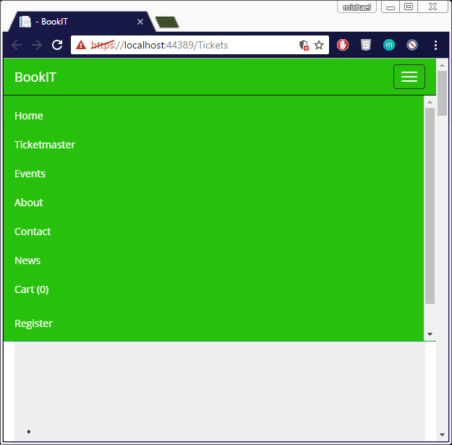

## Widgets

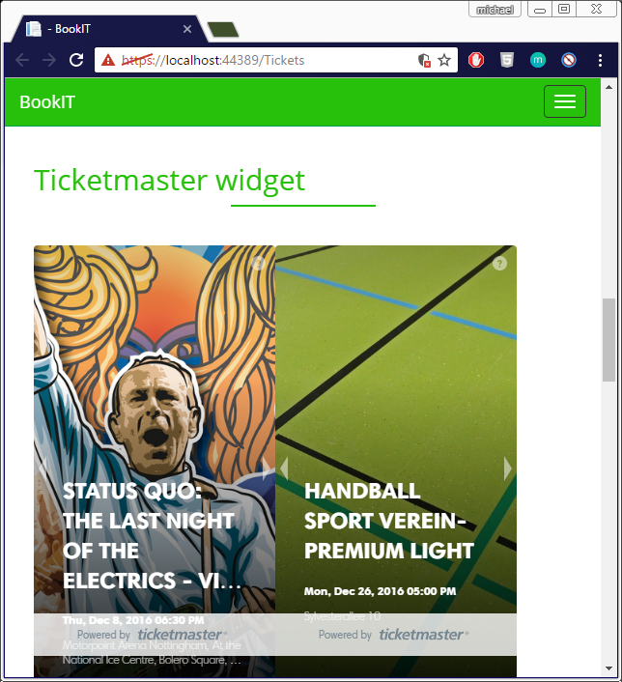

## Delegates

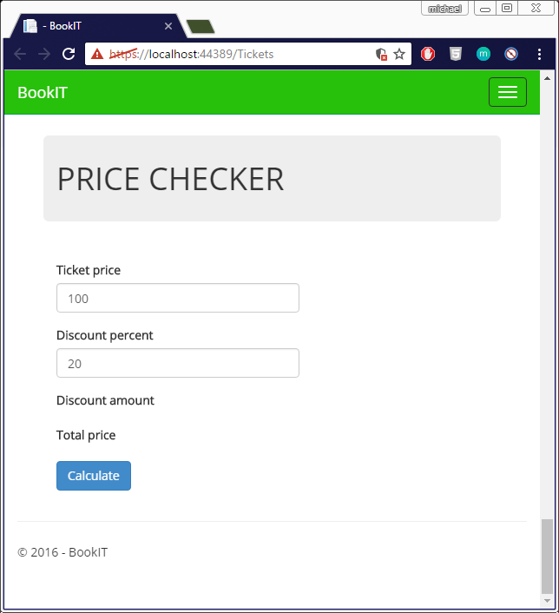

## Divs

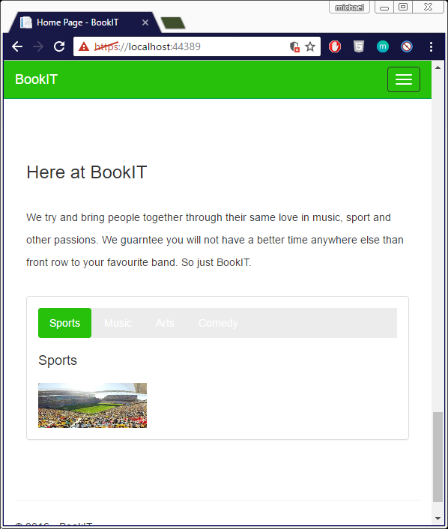

# References

Microsoft ASP.NET Team. (2014-2016). *ASP.net Tutorials.* Available: https://www.youtube.com/. Last accessed 09/12/2016.

unknown. (2016). *PayPal Checkout.* Available: https://developer.paypal.com/. Last accessed 09/12/2016.

Not Known. (2016). *Integrating Google Sign-In into your web app.* Available: [https://developers.google.com/identity/sign-in/web/sign-in. Last accessed 11/11/2016](https://developers.google.com/identity/sign-in/web/sign-in.%20Last%20accessed%2011/11/2016).

Many Authors. (2014-2016). *Web Forms Videos.* Available: https://www.asp.net/web-forms/videos. Last accessed 30/11/2016.